**User’s guide of MedFDTD**

Wang Meng, Yu Dong

Britton Chance Center for Biomedical Photonics

Wuhan National Laboratory for Optoelectronics

Huazhong University of Science and Technology (HUST)

Content

Directory

1. Quick start 3

1.1 Operating environment 3

1.2 Files description 3

1.3 Create a simulation 3

2. Features 4

2.1 Available functions 4

2.2 Available excitation sources 4

2.3 Absorbing boundary 4

2.4 Calculate antenna power 4

2.5 Calculate specific absorption rate (SAR) 4

2.6 Coordinate system and units 4

3. Applications 5

3.1 A simple example: point excitation source spread in vacuum 5

3.2 Dipole antenna: simulation and parameters calculation 6

3.3 SAR calculation: a fat exposure to antenna 7

4. File format 9

4.1 User defined source 9

4.2 Store data and model data 9

4.3 Mass averaged SAR 10

5. Configure 11

**1. Quick start**

1.1 Running environment

User need to set up MPICH2-1.4 to establish parallel computing platform, you can download it from URL: [www.mpich.org/downloads/](http://www.mpich.org/downloads/).

User can compile the software by a GNU standard compilers, such as GCC. It is noteworthy that the mpi header file “mpi.h” and “mpio.h” is different in Windows and UNIX, so we provide two version for download.

1.2 Files description

"3D_FDTD_DEFINES.h": Includes projects, models, storage path, the length unit, variable, function definition;

* "INITIALIZE_DATA_AND_FILES.h": Initialization files, create/release the array;
* "SETUP.h": calculate FDTD parameters, load the external model, the establishment of an internal model to calculate the PML factor, FDTD factor, load user define wave source;
* "BUILDOBJECTS.h": Create models, including single medium rectangular, antenna;
* "POWERSOURCE.h": Generated wave source;
* "COMPUTE.h": Main calculation function, including the FDTD iteration, PML calculations and Poynting vector calculations;
* "WRITEFIELD.h": Save field data;
* "EXTENSIONS.h": Post-process, such as calculate SAR and temperature rise.
* “config.txt”: Configuration file.

1.3 Create a simulation

Creating a simulation in MedFDTD consists of the following steps:

1) Open configuration file “config.txt”.

2) Under label <Path>, set the path of save data and log file.

3) Under label <Time>, set simulation time and time step.

4) Under label <Mesh>, set size of simulation space and space interval.

5) Under label <Absorbing boundary>, set the absorbing boundary, 0 for PEC, 1 for PML and 2 for Mur2.

6) Under label <Power source>, set the power source, include source type, 0 for point feed and 1 for plane wave, location of point feed and wave form. There is a point feed whit 1.8GHz sine wave in the default settings.

7) Under label <Model>, set the path of import model, or build object and dipole antenna. There is none model and object in the default settings.

8) Under label <Field save>, set requesting field results.

9) Under label <SAR>, set requesting specific absorption rate (SAR) results.

10) Under label <Temperature Rise>, set requesting temperature rise results.

10) Run “MedFDTD.exe” with mpich2, input the path of configuration file after mpi parameters. For example: **“mpiexec.exe –n 3 C:\MedFDTD\MedFDTD.exe C:\MedFDTD\config.txt”**.

**2. Features**

2.1 Available functions

By MedFDTD, you can:

* Simulation of electromagnetic radiation, store field data;
* Completely parallel computation;
* Point excitation and plane wave excitation;
* Various absorbing boundary, include PEC, Mur, PML;
* Import model data from hard disk;
* Antenna radiation simulation, calculate radiation power;
* Calculate Specific Absorption Rate (SAR).
* Calculate temperature rise.

2.2 Available excitation sources

* 1. Gaussian pulse, parameters: t0---peak position, pulse_width---pulse width;
  2. Raised cosine pulse, parameters: pulse_width---pulse width;
  3. Derivative Gaussian pulse, parameters: t0---peak position, pulse_width---pulse width;
  4. Modulated Gaussian pulse, parameters: freq---modulation frequency, t0---peak position, pulse_width---pulse width.
  5. Sine wave, parameters: freq---frequency.

2.3 Absorbing boundary

a) Perfect electronic conductor (PEC)

Set “abcNo=0”, the absorbing boundary is PEC, reflect all wave completely.

b) Perfectly matched layer (PML)

Set “abcNo=1”, the absorbing boundary is PML, absorbing all wave. The compute with PML is time consuming, so recommend set the thickness of PML to 7.

c) Mur absorbing boundary (2-order)

Set “abcNo=2”, the absorbing boundary is second-order Mur, absorbing all wave, low precision, but faster than pml, only available in serial execution.

2.4 Calculate antenna power

If create a dipole antenna in label <Antenna>, and the impedance is no-zero, MedFDTD will calculate the antenna available power and estimate the net input power.

2.5 Calculate specific absorption rate (SAR)

The specific absorption rate calculation include two part, local SAR and mass averaged SAR. If need to calculate local SAR or mass averaged SAR, set “save_localSAR_amount” or “Amount of Mass Averaged SAR” to no-zero, then the software will calculate SAR as set.

2.6 Calculate temperature rise

If need to calculate temperature rise, set “need compute temperature rise” to no-zero, “sar_file” to “localsar.txt”, “SAR1g.txt”, “SAR10g.txt” or others. Then the software will calculate temperature rise cause by SAR stored in the “sar_file” in current model.

2.6 Coordinate system and units

The coordinate is ranged from 1 to “_spaceX”, “_spaceY” or “_spaceZ”, where “_spaceX”, “_spaceY” or “_spaceZ” means the length of computational space in x, y and z direction. All objects are placed in this coordinate system. In addition, if you import a model, the coordinate system would be determined by the coordinate system of model.

**3. Applications**

3.1 A simple example: point excitation source spread in vacuum

Open configuration file “config.txt”, setting with follow step:

3.1.1 Path

Under label <Path>, set path of save data by “path_save=PATH”, set path of log file by “path_log=PATH”.

3.1.2 Time

Under label <Time>, set total simulation time step by “nMax=2000”, set time step by “dt=1.925833e-12”.

3.1.3 Mesh

Under label <Mesh>, set size of simulation space by “_spaceX=100,_spaceY=100,_spaceZ=100”, set space interval by “dx=1e-3,dy=1e-3,dz=1e-3”.

3.1.4 Absorbing boundary

Under label <Absorbing boundary>, set absorbing boundary to PML by “abcNo=1”, set “thicknessOfPml=7”.

3.1.5 Power source

Under label <Power source>, set point source by “sourceType=0”, set location of point source by “_isource=50,_jsource=50,_ksource=50”, set polarization by “port=z”, set wave form to 1.8GHz sine wave by “waveform=0”, “amp=1.0”, “freq=1.8e9”.

3.1.6 Field save

Under label <Field save>, in order to save the field data from time step 1 to 2000 in xy plane z=50, set “save_plane_amount=1”, “saveStart=1,saveEnd=2000,saveStep=1,savePlaneNo=1,slice=50”.

3.1.7 Compile and run

Run MedFDTD with following command **“mpiexec.exe –n 3 YourPathOfMedFDTD\MedFDTD.exe YourPathOfConfig\config.txt”**.

3.1.8 Results

The Ex results at time step 150 is shown in figure 3.1.

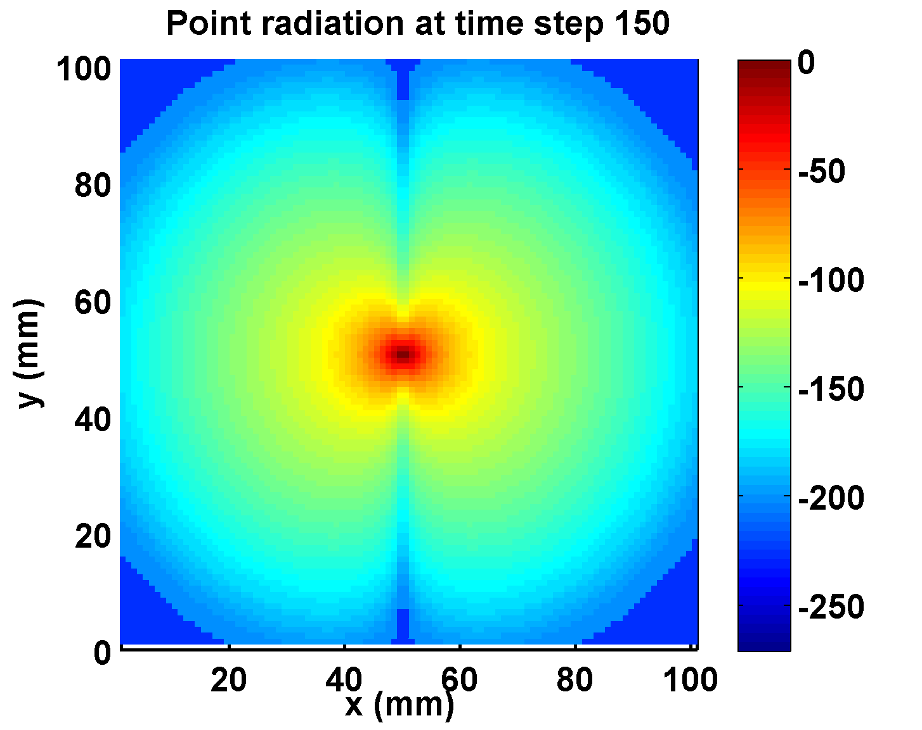

**Figure 3.1: simulate a point source radiation in free space.**

3.2 Dipole antenna: simulation and parameters calculation

Open configuration file “config.txt”, setting with follow step:

3.2.1 Path

Under label <Path>, set path of save data by “path_save=PATH”, set path of log file by “path_log=PATH”.

3.2.2 Time

Under label <Time>, set total simulation time step by “nMax=2000”, set time step by “dt=1.925833e-12”.

3.2.3 Mesh

Under label <Mesh>, set size of simulation space by “_spaceX=100,_spaceY=100,_spaceZ=100”, set space interval by “dx=1e-3,dy=1e-3,dz=1e-3”.

3.2.4 Absorbing boundary

Under label <Absorbing boundary>, set absorbing boundary to PML by “abcNo=1”, set “thicknessOfPml=7”.

3.2.5 Power source

Under label <Power source>, set point source by “sourceType=0”, set location of point source by “_isource=50,_jsource=50,_ksource=50”, set polarization by “port=z”, set wave form to 1.8GHz sine wave by “waveform=0”, “amp=1.0”, “freq=1.8e9”.

3.2.6 Model

Under label <Model>, sub-label <Antenna>, in order to create a dipole antenna, polarization direction is z-axis, and feed point is the point source in 3.2.5, impedance is 73.1Ohm, oscillator length is 39mm, set “antenna_amount=1”, “antenna_direction=3”, “antenna_feed_x=50,antenna_feed_y=50,antenna_feed_z=50”, “antenna_impedance=50.0”, “antenna_length_high=39,antenna_length_low=39”.

3.2.7 Field save

Under label <Field save>, in order to save the field data from time step 1 to 2000 in xoy plane z=50, yoz plane x=50 and xoz plane y=50, set “save_plane_amount=3”, “saveStart=1,saveEnd=2000,saveStep=1,savePlaneNo=1,slice=50”, “saveStart=1,saveEnd=2000,saveStep=1,savePlaneNo=2,slice=50”, “saveStart=1,saveEnd=2000,saveStep=1,savePlaneNo=3,slice=50”.

3.2.7 Compile and run

Run MedFDTD with following command **“mpiexec.exe –n 3 YourPathOfMedFDTD\MedFDTD.exe YourPathOfConfig\config.txt”**.

3.2.4 Results

User can see an averaged radiation power in the end of the output, and instantaneous power is stored in “poynting.txt” under the save path.

The Ex results at time step 120 is shown in figure 3.2.

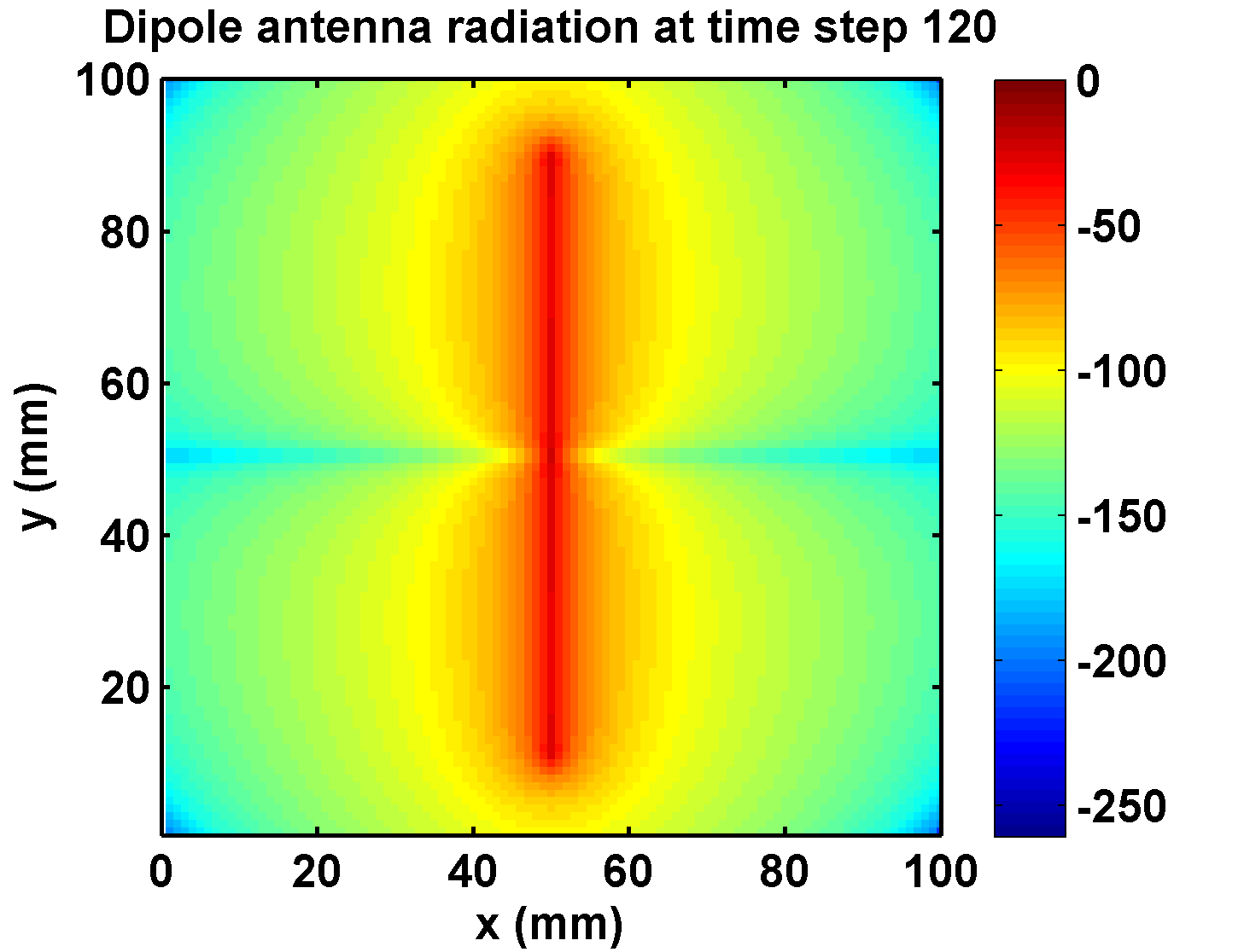

**Figure 3.2: simulation a dipole antenna radiation in free space.**

3.3 SAR calculation: a fat exposure to antenna

Open configuration file “config.txt”, setting with follow step:

3.3.1 Path

Under label <Path>, set path of save data by “path_save=PATH”, set path of log file by “path_log=PATH”.

3.3.2 Time

Under label <Time>, set total simulation time step by “nMax=2000”, set time step by “dt=1.925833e-12”.

3.3.3 Mesh

Under label <Mesh>, set size of simulation space by “_spaceX=100,_spaceY=100,_spaceZ=100”, set space interval by “dx=1e-3,dy=1e-3,dz=1e-3”.

3.3.4 Absorbing boundary

Under label <Absorbing boundary>, set absorbing boundary to PML by “abcNo=1”, set “thicknessOfPml=7”.

3.3.5 Power source

Under label <Power source>, set point source by “sourceType=0”, set location of point source by “_isource=50,_jsource=50,_ksource=50”, set polarization by “port=z”, set wave form to 1.8GHz sine wave by “waveform=0”, “amp=1.0”, “freq=1.8e9”.

3.3.6 Model

Under label <Model>.

a) Sub-label <Build object>, in order to create a fat to absorb the radtation, create a rectangular fat start at (30, 55, 10), and edge length (40, 30, 80), relative permittivity is 5.3, conductivity is 0.08V/m, density is 920 by set “object_num=1”, “3,30,55,10,40,30,80,0.08,5.3,9.2e3”.

b) Sub-label <Antenna>, in order to create a dipole antenna, polarization direction is z-axis, and feed point is the point source in 3.2.5, impedance is 73.1Ohm, oscillator length is 39mm, set “antenna_amount=1”, “antenna_direction=3”, “antenna_feed_x=50,antenna_feed_y=50,antenna_feed_z=50”, “antenna_impedance=50.0”, “antenna_length_high=39,antenna_length_low=39”.

3.3.7 Field save

Under label <Field save>, in order to save the field data from time step 1 to 2000 in xoy plane z=50, yoz plane x=50 and xoz plane y=50, set “save_plane_amount=3”, “saveStart=1,saveEnd=2000,saveStep=1,savePlaneNo=1,slice=50”, “saveStart=1,saveEnd=2000,saveStep=1,savePlaneNo=2,slice=50”, “saveStart=1,saveEnd=2000,saveStep=1,savePlaneNo=3,slice=50”.

3.3.8 SAR

Under label <SAR>. Sub-label<Mass Averaged SAR>, in order to compute 1g mass averaged SAR and 10g mass averaged SAR, set “Amount of Mass Averaged SAR 2”, “Mass Averaged SAR 0.01”, “Mass Averaged SAR 0.001”.

3.3.9 Compile and run

Run MedFDTD with following command **“mpiexec.exe –n 3 YourPathOfMedFDTD\MedFDTD.exe YourPathOfConfig\config.txt”**.

3.3.10 Results

The local SAR data and mass averaged SAR data are stored in file “localSAR.txt” and “MassAveragedSAR.txt”, file format is described in 4.2 and 4.3.

The mass averaged SAR data in z=50 xoy plane is shown in figure 3.3.

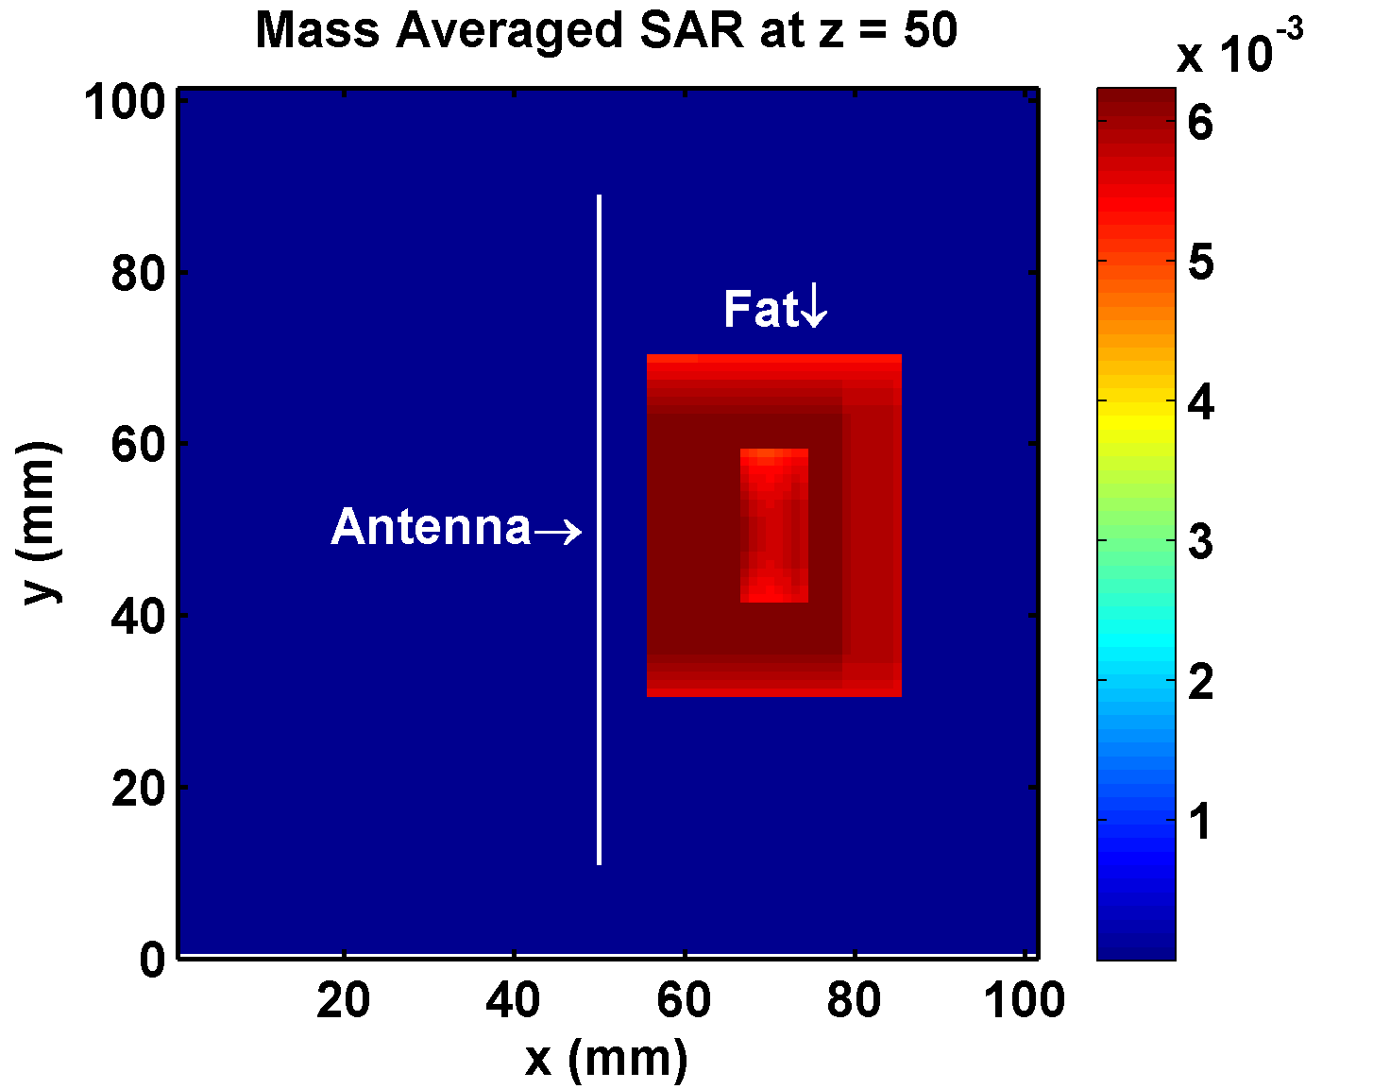

**Figure 3.3: calculate the SAR of fat when near by a dipole antenna.**

3.4 Temperature rise calculation: a fat exposure to antenna

Open configuration file “config.txt”, setting with follow step:

3.4.1 Path

Under label <Path>, set path of save data by “path_save=PATH”, set path of log file by “path_log=PATH”.

3.4.2 Time

Under label <Time>, set total simulation time step by “nMax=2000”, set time step by “dt=1.925833e-12”.

3.4.3 Mesh

Under label <Mesh>, set size of simulation space by “_spaceX=100,_spaceY=100,_spaceZ=100”, set space interval by “dx=1e-3,dy=1e-3,dz=1e-3”.

3.4.4 Absorbing boundary

Under label <Absorbing boundary>, set absorbing boundary to PML by “abcNo=1”, set “thicknessOfPml=7”.

3.4.5 Power source

Under label <Power source>, set point source by “sourceType=0”, set location of point source by “_isource=50,_jsource=50,_ksource=50”, set polarization by “port=z”, set wave form to 1.8GHz sine wave by “waveform=0”, “amp=1.0”, “freq=1.8e9”.

3.4.6 Model

Under label <Model>.

a) Sub-label <Import model>, fill your model file name, media file name and path under this label. In this example, we write a fat model same with 3.3.6.

b) Sub-label <Antenna>, in order to create a dipole antenna, polarization direction is z-axis, and feed point is the point source in 3.2.5, impedance is 73.1Ohm, oscillator length is 39mm, set “antenna_amount=1”, “antenna_direction=3”, “antenna_feed_x=50,antenna_feed_y=50,antenna_feed_z=50”, “antenna_impedance=50.0”, “antenna_length_high=39,antenna_length_low=39”.

3.4.7 Field save

Under label <Field save>, in order to save the field data from time step 1 to 2000 in xoy plane z=50, yoz plane x=50 and xoz plane y=50, set “save_plane_amount=3”, “saveStart=1,saveEnd=2000,saveStep=1,savePlaneNo=1,slice=50”, “saveStart=1,saveEnd=2000,saveStep=1,savePlaneNo=2,slice=50”, “saveStart=1,saveEnd=2000,saveStep=1,savePlaneNo=3,slice=50”.

3.4.8 SAR

Under label <SAR>. Sub-label<Mass Averaged SAR>, in order to compute 1g mass averaged SAR and 10g mass averaged SAR, set “Amount of Mass Averaged SAR 2”, “Mass Averaged SAR 0.01”, “Mass Averaged SAR 0.001”.

3.4.9 Temperature rise

Under label <Temperature Rise>, set “need computer temperature rise 1”, “sar_file=SAR10g.txt”, “ds=1e-3”, “dt_T=1e-3”, “max time=1800”, then MedFDTD will compute the temperature rise by 10g SAR in 1800 second.

3.4.9 Compile and run

Run MedFDTD with following command **“mpiexec.exe –n 3 YourPathOfMedFDTD\MedFDTD.exe YourPathOfConfig\config.txt”**.

**4. File format**

4.1 User defined source

The format of user defined source is as following.

|  |  |
| --- | --- |
| Number of rows | |
| Voltage | Row |
| Voltage | Row |
| … | … |

4.2 Store data and model data

The files format, such as field data files (ex, hx, etc.), model data files (sigma, epsilon, rho), local SAR data, are written as following.

Field data:

Xoy plane:

For Tstart to Tend

For Ystart to Yend

For Xstart to Xend

{…}

End

fprintf(fp, “\n”);

End

End

Yoz plane:

For Tstart to Tend

For Zstart to Zend

For Ystart to Yend

{…}

End

fprintf(fp, “\n”);

End

End

Xoz plane:

For Tstart to Tend

For Zstart to Zend

For Xstart to Xend

{…}

End

fprintf(fp, “\n”);

End

End

Model data:

For Zstart to Zend

For Ystart to Yend

For Xstart to Xend

{…}

End

fprintf(fp, “\n”);

End

End

Media data:

id sigma, epsilon, rho, c, K, B

id sigma, epsilon, rho, c, K, B

id: 0 to vacuum and 1 to PEC, so the user’s define id must bigger than 2.

sigma: conductivity(V/m).

epsilon: relative permittivity.

rho: density(kg/m3).

C: specific heat capacity(J/(kg·℃)).

K: thermal conductivity(J/(s·m·℃)).

B: blood perfusion(J/(s·m·℃)).

Local SAR data:

Xoy plane:

For Ystart to Yend

For Xstart to Xend

{…}

End

fprintf(fp, “\n”);

End

Yoz plane:

For Zstart to Zend

For Ystart to Yend

{…}

End

fprintf(fp, “\n”);

End

Xoz plane:

For Zstart to Zend

For Xstart to Xend

{…}

End

fprintf(fp, “\n”);

End

4.3 Mass averaged SAR

x y z SAR

x y z SAR

…

5. Configure

All configure is saving in “config.txt”, and the form is shown as following.

1. **<Path>**
2. path_save=F:\work\TestData\

The path to save field data and SAR data.

1. **<Time>**
2. nMax=2000

Max simulation time step.

1. Convergence

收敛判定，正弦波时，判定前后两个周期，其他波时，判定总时间步的1/100.判定参数为全计算区域的均方根之和。

1. dt=1.925833e-012

Time step(second), must be met the stability condition.

1. **<Mesh>**
2. _spaceX=20,_spaceY=20,_spaceZ=90

Size of simulation space(cell).

1. dx=1.000000e-003,dy=1.000000e-003,dz=1.000000e-003

Space interval(meter).

1. padding=0

Size of blank area around the simulation space(cell).

1. **<Absorbing boundary>**
2. abcNo=1

Absorbing boundary No., 0 for PEC, 1 for PML and 2 for Mur2.

1. thicknessOfPml=7

Thickness of PML absorbing boundary, only available when absorbing boundary is PML.

1. **<Power source>**
2. sourceType=0

Type of source, 0 for point source and 1 for plane wave.

1. _isource=11,_jsource=11,_ksource=45

Point source: location of the feed point(x,y,z).

Plane wave: normal vector of the incident plane.

1. port=z

Voltage polarization, means the exciation voltage Ex, Ey or Ez.

1. waveForm=0

Wave form: -1-->User defined

* + - 1. 0-->Sine wave
      2. 1-->Gaussian pulse
      3. 2-->raised cosine pulse
      4. 3-->differential Gaussian pulse
      5. 4-->3-truncated cosine wave
      6. 5-->modulation Gaussian pulse

1. amp=1.000000

Amplitude of voltage(V).

1. freq=1.800000e+009

Frequency of source, available when wave form is sine or modulation Gaussian pulse.

1. t0=150

Peak time, available when wave form is Gaussian pulse, differential Gaussian pulse or modulation Gaussian pulse.

1. pulse_width=120

Pulse width, available when wave form is Gaussian pulse, raised cosine, differential Gaussian pulse, 3-truncated cosine or modulation Gaussian pulse.

1. pathSRC=C:\source.txt

Path of the user defined source, available when “waveform=-1”.

1. **<Model>**
2. -<Import model>
3. path_data=F:\ModelData

Path of the model need to import.

1. model_name=model.txt

Model file name.

1. media_name=media.txt

Media file name.

1. media_dispersion=1

值为1则会考虑色散介质，对应的媒质参数文件格式应按照色散介质格式来写。

1. mediaNum=0

Amount of media in the media file.

1. -<Build object>
2. object_num=1

Amount of object need to create.

1. 3,13,2,5,4,6,80,0.100000,81.000000,1000000.000000

Build object, need 10 parameters: object number, (vector 1), (vector 2), (vector 3).

Object number: 1-->create a line (1D object)

* + - * 1. 2-->create a rectangle (2D object)
        2. 3-->create a cuboid (3D object)

Vector 1: the starting coordinates(x,y,z).

Vector 2: if object number is 1 or 2, vector 2 means the ending coordinates(x,y,z), if object number is 3, vector 2 means the length in x, y or z-axis.

Vector 3: media parameters, (conductivity, relative dielectric constant, density).

1. -<Antenna>
2. antenna_amount=1

Amount of dipole antenna need to create.

1. antenna_direction=3

Polarization: 1-->Ex, 2-->Ey, 3-->Ez.

1. antenna_feed_x=11,antenna_feed_y=11,antenna_feed_z=45

Location of antenna feed point(x,y,z), for the transmitting antenna, equal to the location of point source.

1. antenna_impedance=50.000000

Impedance of the antenna.

1. antenna_length_high=41,antenna_length_low=41

Oscillator length of antenna.

1. **<Field Save>**
2. save_plane_amount=1

Amount of requesting field results.

1. saveStart=1,saveEnd=2000,saveStep=1,savePlaneNo=1,slice=45

Set field results, form is: starting time step, ending time step, interval time step, plane No.(1-->xoy, 2-->yoz, 3-->xoz), save silce. In the line 41, save field results from time step 1 to 2000, save interval is 1 time step, save plane is plane xoy, z=45.

1. **<SAR>**
2. -<Whole body SAR>
3. Whole body SAR 1(need compute Whole body SAR) or 0(not need)
4. -<Mass Averaged SAR>
5. Amount of Mass Averaged SAR 2

Amount of mass averaged SAR.

1. Mass Averaged SAR 0.0001
2. Mass Averaged SAR 0.001

Set request mass(kg) of the mass averaged SAR.

1. -<LocalSAR>
2. save_localSAR_amount=1

Amount of local SAR.

1. saveLocalSARLength=2000,saveLocalSARPlaneNo=1,LocalSARslice=1

Set local SAR results, form is: starting time step, ending time step, plane No.(1-->xoy, 2-->yoz, 3-->xoz), calculate silce. In the line 51, calculate local SAR in plane xoy z=45, and using field data is from time step 1713 to 2000(here is 288 time step, a period of 1.8GHz sine wave when 1 time step is 1.925833e-012 second).

1. **<Temperature Rise>**
2. need compute temperature rise 1(need compute temperature rise) or 0(not need)
3. sar_file=SAR10g.txt

Load 10 g mass averaged sar which is stored in the “.\SAR10g.txt” to compute temperatre rise.

1. ds=1e-3

Space interval (meter).

1. dt_T=1e-3

Time step (second), must be met the stability condition.

1. max time=1800

Simulation time (second) in the temperature rise calculation.